12:35:50  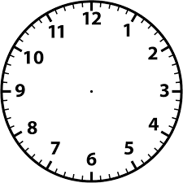 | 09:28:40  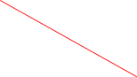  
15:25:33   | 07:40:10
11:55:45 | 24:00:00
13:25:55 | 08:12:20
16:45:15 | 07:55:22
10:45:20 | 19:30:55

