|  |  |  |  |  |
| --- | --- | --- | --- | --- |
| Beschrijving: https://gallery.mailchimp.com/6d6afac4f546351752a1f1f54/images/f866437d-6e0e-47b8-8a8c-0df851073d6c.gif  Bachelor Lager Onderwijs  campus Heverlee en Diest |  | **Naam** : ......................................................................  **Nr**. : ....... |  | **Datum** : ..../..../.... |
|  |  |  |  |  |

cijferen

**Vind de zin**

16 541 + 13 517= 92 487- 13 512=

S: S: 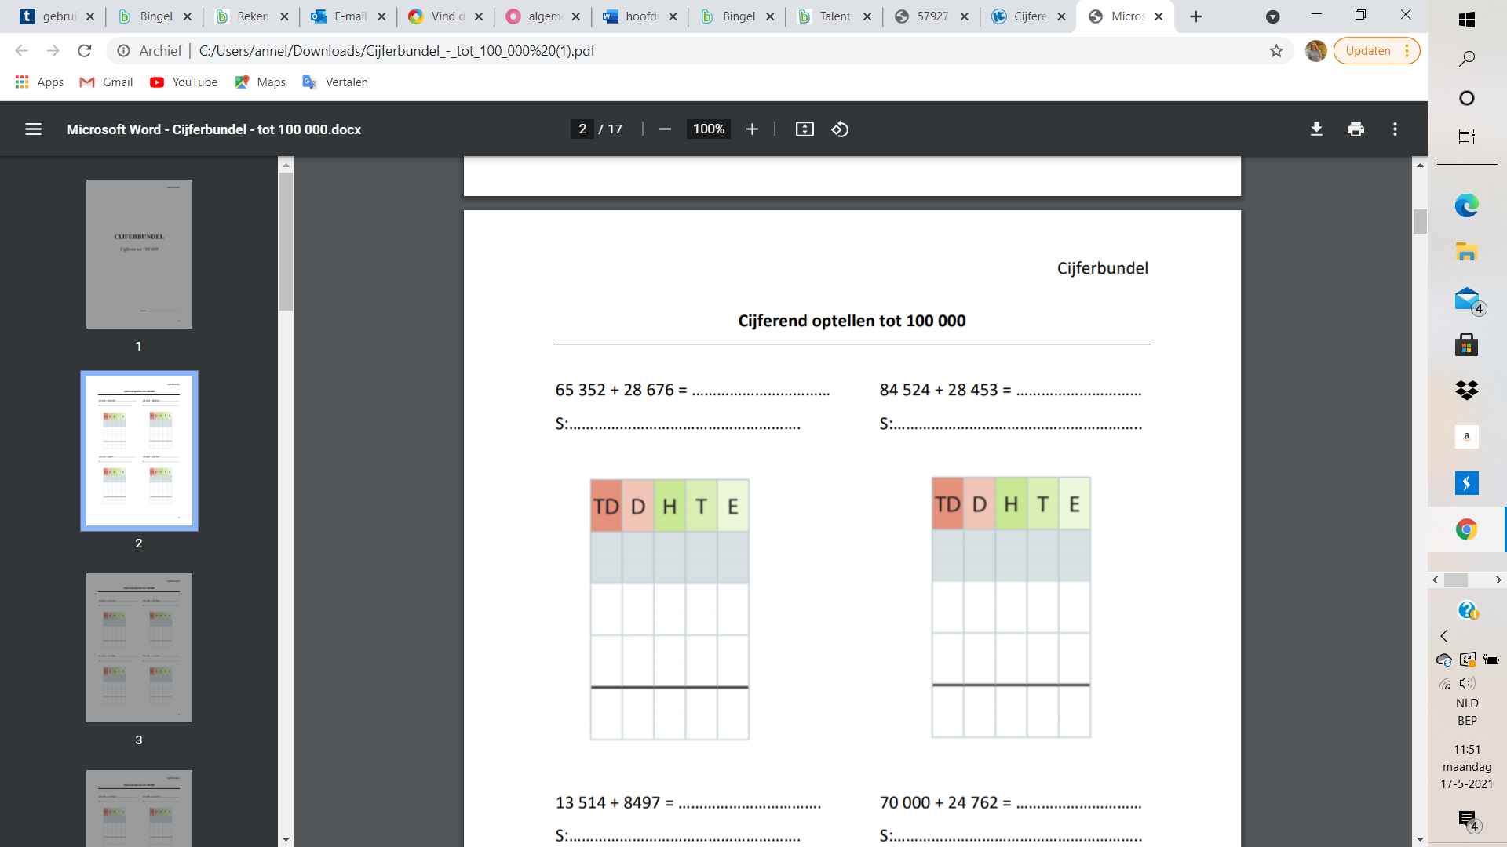 

32 560 x 4= 74 332 : 8=

S: S:

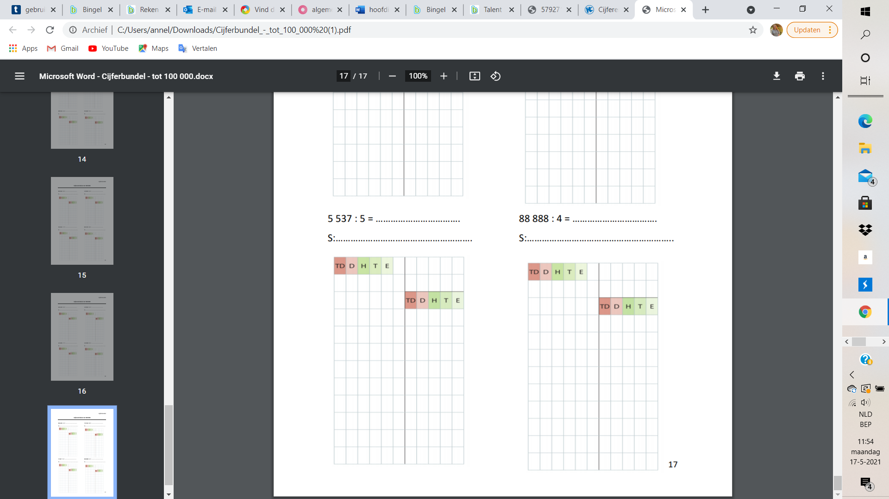

|  |  |  |  |  |
| --- | --- | --- | --- | --- |
| Beschrijving: https://gallery.mailchimp.com/6d6afac4f546351752a1f1f54/images/f866437d-6e0e-47b8-8a8c-0df851073d6c.gif  Bachelor Lager Onderwijs  campus Heverlee en Diest |  | **Naam** : ......................................................................  **Nr**. : ....... |  | **Datum** : ..../..../.... |
|  |  |  |  |  |

38,97 + 205,46= 0,837 + 0,9=

S: S:

 

89,69 - 63,85= 98,40 - 25=

S: S:

 

|  |  |  |  |  |
| --- | --- | --- | --- | --- |
| Beschrijving: https://gallery.mailchimp.com/6d6afac4f546351752a1f1f54/images/f866437d-6e0e-47b8-8a8c-0df851073d6c.gif  Bachelor Lager Onderwijs  campus Heverlee en Diest |  | **Naam** : ......................................................................  **Nr**. : ....... |  | **Datum** : ..../..../.... |
|  |  |  |  |  |

7 x 6,47= 187,60 : 4=

S: S:



Wat is de zin?

……………………….. …………………………. ………………………….. …………….

………………………… ………………………… ………………………….. ……………..

……………………….. …………………………!

30 058

HET

78 975

4de

130 240

leerjaar

9 291,5

is

244,43

de

1,737

tofste

25,84

klas

73,40

van

45,29

de

46,90

school